**Step 1 - Puppet Pre-Installation**

**In this step, we will perform some tasks including installation and configuration on both servers puppet master and puppet agent. We will configure the host's file, synchronizing time using the NTP server, Disable SELinux, and add the puppet repository to the system.**

**- Configure hosts**

**Connect to the puppet master and agent using your root user.**

***ssh root@10.0.15.10  
ssh root@10.0.15.11***

**Now edit the hosts using**[**vim**](https://www.howtoforge.com/vim-basics)**editor.**

***vim /etc/hosts***

**Add the following configuration to the end of the line.**

***10.0.15.10      master.hakase.io  
 10.0.15.11      agent.hakase.io***

**Save and exit.**

**Now test using the ping command.**

***ping master.hakase.io  
ping agent.hakase.io***

**And make sure you get the server IP address 10.0.15.10 and 10.0.15.11.**

**[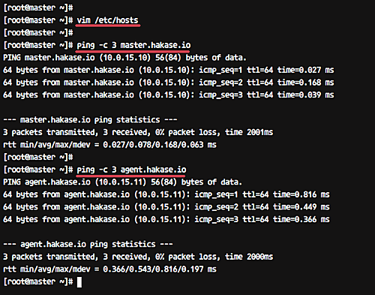](https://www.howtoforge.com/images/how_to_setup_puppet_master_and_agent_on_centos_7/big/1.png)**

**- Configure NTP Server**

**It's very important to keep in synchronization the time between master and agent server.**

**Install the NTP packages on both servers using the yum command.**

***yum -y install ntp ntpdate***

**After the installation is complete, choose the NTP pool as you want by running the command as below.**

***sudo ntpdate 0.centos.pool.ntp.org***

**Now start the NTP service and enable it to launch everytime at system boot.**

***sudo systemctl start ntpd  
sudo systemctl enable ntpd***

**NTP installation and configuration has been completed.**

**[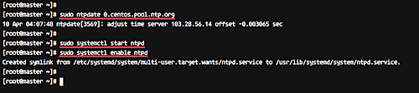](https://www.howtoforge.com/images/how_to_setup_puppet_master_and_agent_on_centos_7/big/2.png)**

**- Disable SELinux**

**Edit the SELinux configuration using vim.**

***vim /etc/sysconfig/selinux***

**Change the SELINUX value to 'disabled'.**

***SELINUX=disabled***

**Save and exit.**

**- Add Puppet Repository**

**Now add the puppet repository to the system using the rpm command below.**

***rpm -Uvh https://yum.puppetlabs.com/puppet5/puppet5-release-el-7.noarch.rpm***

**[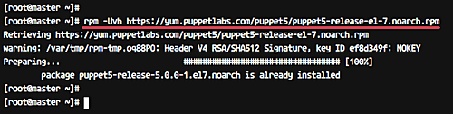](https://www.howtoforge.com/images/how_to_setup_puppet_master_and_agent_on_centos_7/big/3.png)**

**When it is complete, reboot both servers.**

***reboot***

**Now we're ready for puppet installation and configuration.**

**Step 2 - Install and Configure Puppetserver**

**In this step, we will install the puppetserver on the master.hakase.io server. Install puppetserver using the yum command below.**

***sudo yum -y install puppetserver***

**After the installation is complete, we need to configure the memory allocation for puppetserver. We will set the max memory allocation for puppetserver to 1GB.**

**Edit the 'puppetserver' configuration using vim.**

***vim /etc/sysconfig/puppetserver***

**Now change the line as below.**

***JAVA_ARGS="-Xms1g -Xmx1g ...."***

**Save and exit.**

**Next, go to the puppet configuration directory and edit the 'puppet.conf' file.**

***cd /etc/puppetlabs/puppet  
vim puppet.conf***

**Add the following configuration.**

***[master]  
 dns_alt_names=master.hakase.io,puppet  
   
 [main]  
 certname = master.hakase.io  
 server = master.hakase.io  
 environment = production  
 runinterval = 1h***

**Save and exit.**

**Now start the puppetserver and enable it to launch everytime at startup.**

***systemctl start puppetserver  
systemctl enable puppetserver***

**The Puppetserver installation and configuration has been completed successfully.**

**[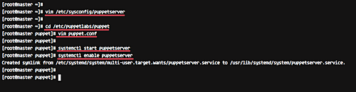](https://www.howtoforge.com/images/how_to_setup_puppet_master_and_agent_on_centos_7/big/4.png)**

**If you're using firewalld on your system, add the puppetserver port to the list using the firewall-cmd command below.**

***firewall-cmd --add-port=8140/tcp --permanent  
firewall-cmd --reload***

**[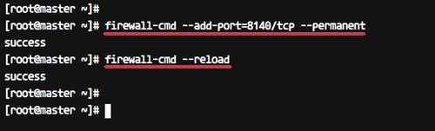](https://www.howtoforge.com/images/how_to_setup_puppet_master_and_agent_on_centos_7/big/5.png)**

**Step 3 - Install and Configure Puppet Agent**

**We will install the puppet agent on the 'agent.hakase.io' server.**

**Install puppet agent using the yum command below.**

***yum install -y puppet-agent***

**After the installation is complete, go to the puppet configuration directory and edit the puppet.conf file.**

***cd /etc/puppetlabs/puppet  
vim puppet.conf***

**Paste the following configuration.**

***[main]  
 certname = agent.hakase.io  
 server = master.hakase.io  
 environment = production  
 runinterval = 1h***

**Save and exit.**

**Next, we will register the puppet agent to the puppet master.**

**Run the command below on the puppet agent shell.**

***/opt/puppetlabs/bin/puppet resource service puppet ensure=running enable=true***

**The puppet agent is now running on the server, and it's attempting to register itself to the puppet master.**

**Now back to the puppet master shell and run the command below.**

***/opt/puppetlabs/bin/puppet cert list***

**And you will get the pending Certificate Signing Request (CSR) from the puppet agent server 'agent.hakase.io'.**

**Sign the certificate using the command below.**

***/opt/puppetlabs/bin/puppet cert sign agent.hakase.io***

**And the result should be similar to the following:**

**[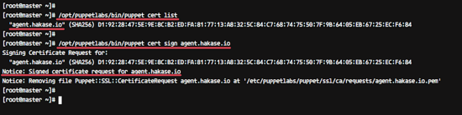](https://www.howtoforge.com/images/how_to_setup_puppet_master_and_agent_on_centos_7/big/6.png)**

**The puppet agent is now running on the system, and the certificate for the agent has been signed by the puppet master.**

**Step 4 - Verify the Puppet Agent Configuration**

**After the puppet master signed the certificate file for the agent, run command below on the puppet agent to verify the configuration.**

***/opt/puppetlabs/bin/puppet agent --test***

**And you will get the result as shown below.**

**[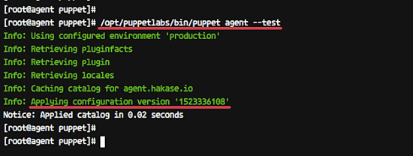](https://www.howtoforge.com/images/how_to_setup_puppet_master_and_agent_on_centos_7/big/7.png)**

**The Puppet agent pulled the configuration from the puppet master and applied to the server without any error.**

**Step 5 - Create First Manifest**

**The puppet master and agent installation and configuration have been completed. And for this step, we will create a simple manifest for testing.**

**We will create the manifest for Apache httpd web server installation.**

**On the puppet master server, go to the '/etc/puppetlabs/code/' directory and create the new manifest file 'site.pp' using vim.**

***cd /etc/puppetlabs/code/  
cd environments/production/manifests***

**Create new manifest file.**

***vim site.pp***

**Paste the following configuration.**

***node 'agent.hakase.io' {  
     package { 'httpd':  
         ensure  => "installed",  
     }  
     service { 'httpd':  
         ensure => running,  
     enable => true  
     }  
 }***

**Save and exit.**

**Now open the puppet agent server shell and run the command below.**

***/opt/puppetlabs/bin/puppet agent --test***

**The command will retrieve new manifest configuration file from the puppet master and then apply it to the agent server.**

**Following is the result.**

**[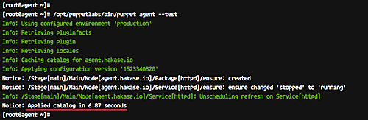](https://www.howtoforge.com/images/how_to_setup_puppet_master_and_agent_on_centos_7/big/8.png)**

**Open your web browser and type the IP address of the puppet agent.**

***http://10.0.15.11/***

**And you will get the default HTTP page as below.**

**The httpd web server has been installed using the puppet manifest.**

**Installation and configuration of the Puppet Master and Puppet Agent on CentOS 7 has been completed successfully.**

**Reference**